

**THE NATIONAL INSTITUTE OF**

**ENGINEERING**

**MYSURU-570008**

**DEPARTMENT OF ELECTRONICS AND COMMUNICATION ENGINEERING**

**DIGITAL PROJECT [EC3C02] –3rd Semester**

**Synopsis On**

**Light Detector using IC 7400**

**Under the guidance of:**

**Nandhini S P**

Asst.Professor, Dept. of ECE.

**Submitted By:**

Suraj U Mogali : 4NI18EC093

Prajwal S D : 4NI18EC052

**ABSTRACT**

Simple light detector is a device that uses 74LS00 NAND gate chip and photo resistor to effectively detect light.

The circuit has 9V supply voltage that drives the 74LS00 NAND gate chip, which is connected to pin 14 and pin 7 respectively, connected to the ground. The voltage divider circuit is composed of a photo resistor and a 6.8kΩ fixed resistor where voltage is distributed across the components in direct proportion to the amount of resistance each component offers. The more resistance a component offers in relation to the other, the more voltage that will fall across that component. When a photo resistor is exposed to darkness, it has very high resistance, in the order of a few Mega ohms (MΩ). With high resistance, most of the voltage from the power supply feeding the voltage divider circuit falls across the photo resistor with very little voltage falling across the 6.8kΩ fixed resistor. Thus, when connected to the inputs of NAND gate, with voltage so high, the NAND gate will essentially interpret the voltage divider as HIGH or logic 1. When the voltage feeding the inputs of a NAND gate are greater than half of the power supply voltage, it will interpret it as a HIGH value. When a photo resistor is exposed to bright light, its resistance drops dramatically and significantly turns ON the LED.

This project can be integrated to security or safety devices such as burglar alarm that constantly senses a beam of light where any changes in light cause it to alarm. Moreover, it can be used to motion sensing devices as well as to computers, wireless phones and television to automatically control the brightness of a screen especially in low-light or high light situations.

**Table of Contents**

1. Introduction
2. Block diagram with working explanation
3. Hardware tools used
4. Applications
5. Limitations
6. Future enhancement
7. References

Introduction



In this project, we will build a light detector circuit using a NAND gate chip.

A light detector circuit is a circuit that can detect light.

When a bright light shines on the circuit, such as from a flashlight, we will make it so that a buzzer turns on.

The circuit is very basic. The component that will allow us to detect light is a photo resistor. We will use a photo resistor’s light-sensing ability to detect whether the circuit is exposed to darkness or bright light. How this works is that a photo resistor’s resistance changes in proportion to the amount of light it is exposed to. In darkness, it has very high resistance. In bright light, its resistance drops dramatically. If placed in a voltage divider circuit with a fixed resistor, we can exploit this resistance-altering behaviour so that when connected to a NAND gate, we can produce a logic HIGH output when the photo resistor is exposed to bright light and a logic LOW output when the photo resistor is exposed to darkness. All of this will be explained in detail below how exactly this works. But realize that a photo resistor’s resistance-changing ability allows us to distinctly know whether it is exposed to darkness or bright light. Knowing this, we can effectively build a light detector circuit.

**Working:**

The schematic diagram of the light detector using a NAND gate chip is shown below.  
  
 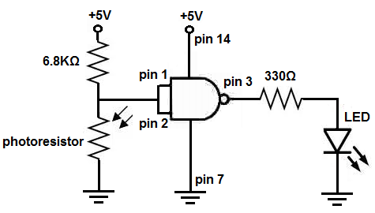

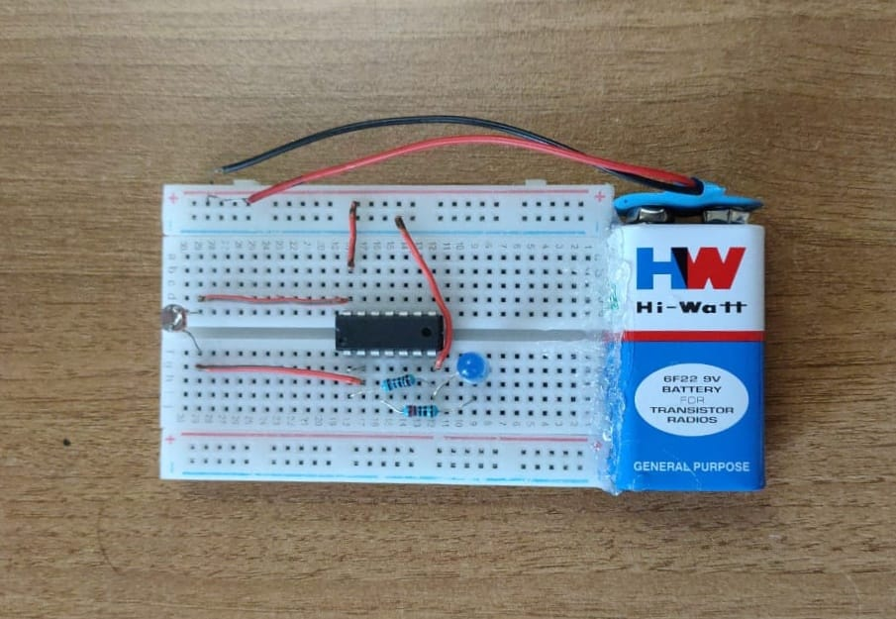

First and foremost, we must give power to the NAND gate chip. We will feed it 5V of power, so we give +5V to pin 14 and we connect pin 7 to GND. This establishes power to the chip.

The circuit is very basic. The component that allows us to detect light is a photo resistor. We set up a voltage divider circuit composed of a photo resistor and a 6.8KΩ fixed resistor. In a voltage divider circuit, voltage is distributed across the components in direct proportion to the amount of resistance each component offers. The more resistance a component offers in relation to the other, the more voltage that will fall across that component. This is shown in the ohm's law formula, *V= IR*. You can see the direct relationship between voltage and resistance in the formula. The greater the resistance a component offers, the more voltage that falls across it. Conversely, the less resistance a component offers, the less voltage that falls across it.

When a photo resistor is exposed to darkness, it has very high resistance, in the order of a few mega ohms (MΩ). With resistance this high, most of the voltage from the power supply feeding the voltage divider circuit falls across the photo resistor, with very little voltage falling across the 6.8KKΩ fixed resistor. Thus, when connected to the inputs of NAND gate, with voltage so high, the NAND gate will essentially interpret the voltage divider as if it were HIGH (or 1). When the voltage feeding the inputs of a NAND gate are greater than half of the power supply voltage, it will interpret it as a HIGH value. Since we will tie both inputs together, the NAND gate will interpret this as two ones, so it will output a 0 (or LOW), which means the output will be drawn down to GND and the load will not be powered.

NAND gate logic, two 1s gives a 0. This is the only time we get an output value of 0 in NAND gate logic. If a 0 is present anywhere in the inputs, including twice, the NAND gate will output a 1.

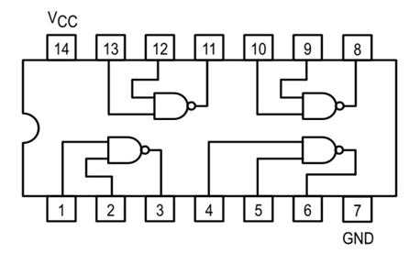 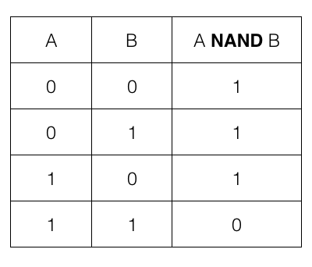

When a photo resistor is exposed to bright light, its resistance drops dramatically, in order of 20-30KΩ, or less, depending on the type in use. With this resistance this low, most of the voltage from the power supply falls across the 33KΩ resistor, and less than half are falling across the photo resistor. With voltage this low, the NAND gate will interpret as a logic level of 0. Thus, the output will be drawn up to Vcc and the load, the buzzer, will be powered on.

So you can see how this voltage divider circuit allows us to get 2 different logic levels produced by the NAND gate chip in different lighting conditions.

**Components :**

* IC 7400
* Resistor 220k
* Resistor 10k
* LDR
* Connecting wires
* LED

**Applications of LDR**

* Light dependent resistors are simple and low cost devices.
* These devices are used where there is a need to sense the presence and absence of light is necessary.
* These resistors are used as light sensors and the applications of LDR mainly include alarm locks, street lights, light intensity meters, burglar alarm circuits.

**Limitations**

* They require a few milliseconds or more to respond fully to the changes in light intensity.
* They will take few seconds to return to their normal dark resistance once light is removed.
* The sensitivity and resistance range of the LDRs will vary from one device to another.
* They are slow (at least compared to photo diodes), so they are suitable for indicating light levels, but not suitable for receiving optical communication.
* They are strongly temperature dependent, so they are not suitable for stable repeatable precision light level measurement.

**Future Enhancement**

**The solar powered LED streetlight with auto intensity control the electric charge and intensity of lights.This project can be enhanced by using the timer based products and photo sensor product.To improve lightning we use LED panel**

**References:**

**This project consists of all the information and the components required. For further information visit the link mentioned below**

[**https://www.electronicshub.org/light-detector-using-ldr/**](https://www.electronicshub.org/light-detector-using-ldr/)

**https://circuitdigest.com/electronic-circuits/nand-gate-circuit-diagram**

|  |  |
| --- | --- |
| **Project Coordinator** | **Project Guide** |
| Mr.RohithPrasanna | Nandhini S P |
| Assistant Professor, Dept. of ECE | Assistant Professor, Dept. of ECE |
| NIE, Mysuru | NIE, Mysuru |